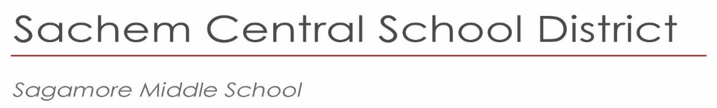

January 2024

Dear Parents and Guardians:

The Sagamore Guidance Department will begin the process of programming your child for eighth grade. To better prepare you and your child, there are several dates you need to be aware of.

**The week of January 15th,** all 7th graders will attend a meeting during their Social Studies classes to discuss information related to the 8th grade schedule. Students will be filling out a google form and selecting their Music choice.

**All students will be able to select General Music 8, Chorus 8, Band 8 or Orchestra 8.**

The music course will be part of the nine period day. Performing groups will have lessons on a rotating basis. If you are currently participating in a performing music group and would like to continue, please choose that class. If you are not presently in a performing music group and wish to do so during the 2024-2025 school year, an audition will be required. Otherwise, students should select General Music-8.

**Your child’s teachers** will make placement recommendations for Math, English, Social Studies, Science and World Languages for the 2024-2025 school year. Any student needing an Academic Intervention Service (AIS) course in English or Mathematics will be scheduled accordingly. **All student course selections will be posted on the Parent Portal in the spring of 2024.**

**Please keep in mind that all recommendations are tentative pending the results of your child’s performance in June.** Please contact the Guidance office at (631) 696-8600, ext. 3 with any questions.

Sincerely,

# Lisa Johnson Principal

*Principal*   
Lisa Johnson  
ljohnson5@sachem.edu

*Assistant Principals*

Ralph Carusillo

Kaleigh Sidaras

*Superintendent of Schools*  
Christopher J. Pellettieri, Ed.D.

|  |
| --- |
| 57 Division Street |
| Holtsville, NY  11742 |
| 631.696.8600 |
|  |
|  |

www.sachem.edu